1. **INTRODUCTION**
   1. **OVERVIEW:**

Under the scheme of Naan Mudhalvan we had done a salesforce project in the field of the Build an Event management. In this project we had done one empathy map, brainstorm and 8 milestones for event management.

* 1. **PURPOSE:**

This project aims to provide a real- time knowledge to the students about salesforce. This project will also help those professionals who are in cross-technology and want to switch to salesforce. With the help of this project we gained the knowledge about salesforce and can include in it our resume as well.

1. **PROBLEM DEFINITION AND DEFINE THINKING:**

**EMPATHY MAP:**

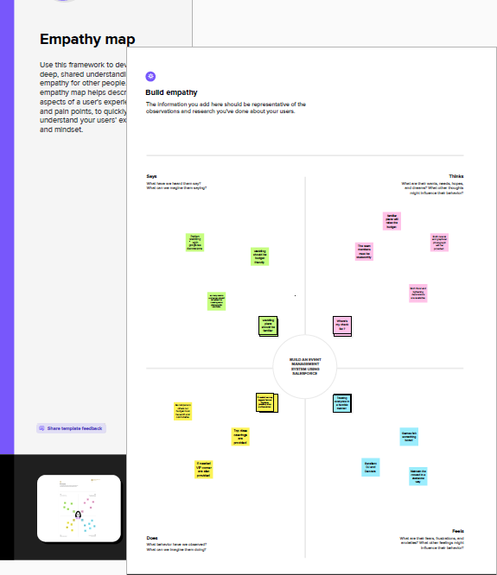

**IDEATION AND BRAINSTORMING MAP:**

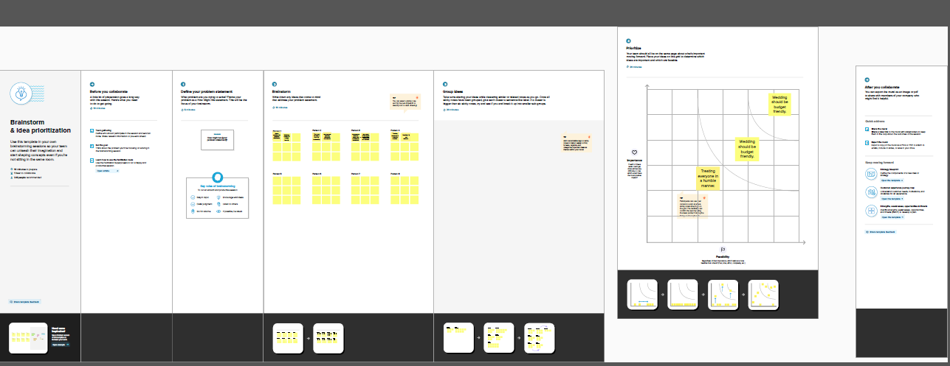

1. **RESULT:**

**3.1 DATA MODEL:**

|  |
| --- |
| **OBJECT NAME FIELD IN THE OBJECT** |

|  |  |  |  |  |  |  |  |
| --- | --- | --- | --- | --- | --- | --- | --- |
| 1. **EVENT** | |  |  | | --- | --- | | **FIELD LABEL** | **DATA TYPE** | | CITY | TEXT AREA | | SCART DATA | DATA/TIME | |
| 1. **ATTENDEE** | |  |  | | --- | --- | | **FIELD LABEL** | **DATA TYPE** | | PHONE | PHONE | | ID | AUTONUMBER | | EVENT NAME | MASTER-DETAIL RELATIONSHIP | | E-MAIL | E-MAIL | | TICKET | TICKETLIST | |
| 1. **SPEAKER** | |  |  | | --- | --- | | **FIELD LABEL** | **DATA TYPE** | | BIO | TEXT AREA | | E-MAIL | E-MAIL | | EVENT NAME | LOOK-UP RELATIONSHIP | |
| 1. **VENDOR** | |  |  | | --- | --- | | **FIELD LABEL** | **DATA TYPE** | | E-MAIL | E-MAIL | | PHONE | PHONE | | E-MAIL | E-MAIL | | SURVICE PROVIDER | TEST AREA | | EVENT NAME | LOOK-UP RELATIONSHIP | |

**3.2 ACTIVITY AND SCREENSHOT:**

**MILESTONE 1:**

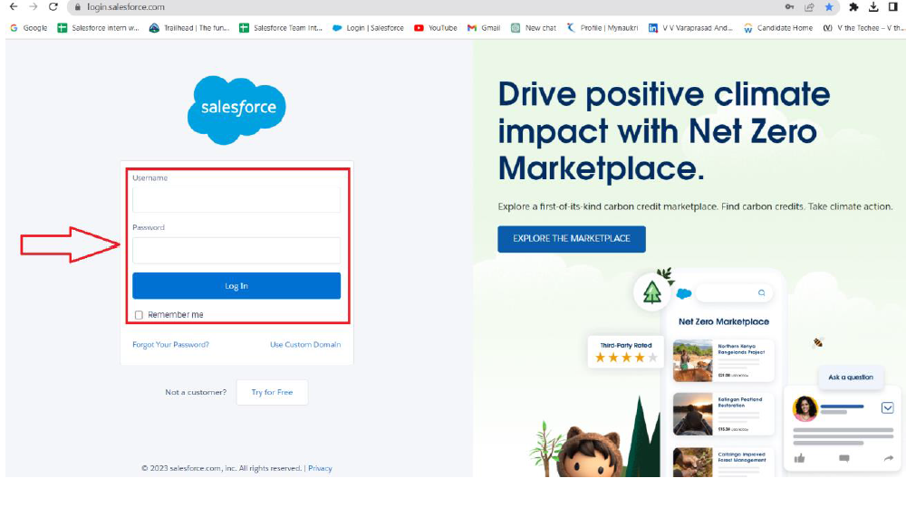

**MILESTONE 2:**

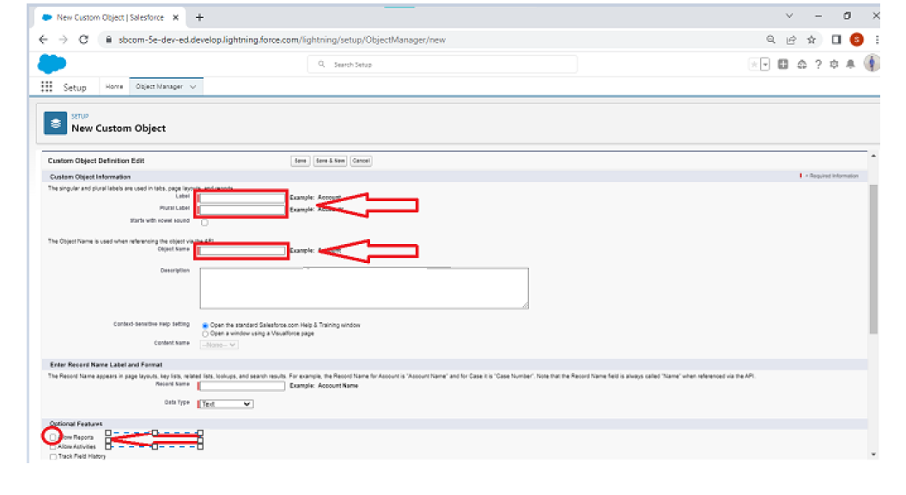**MILESTONE 3:**

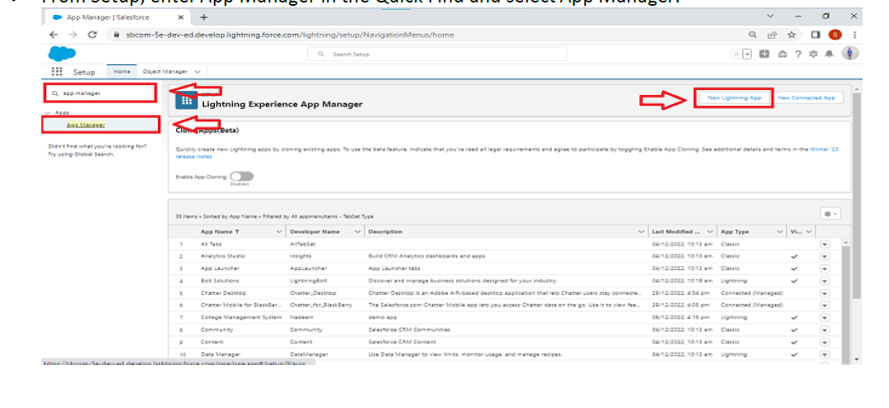

**MILESTONE 4:**

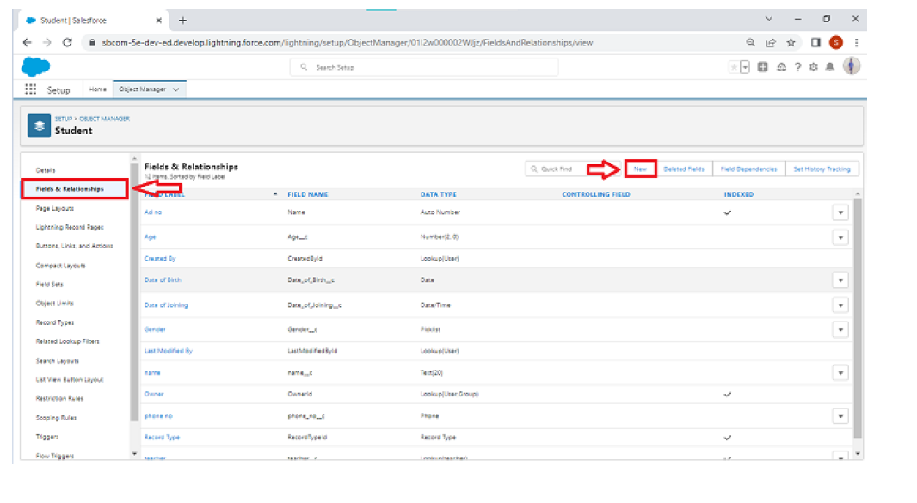

**MILESTONE 5:**

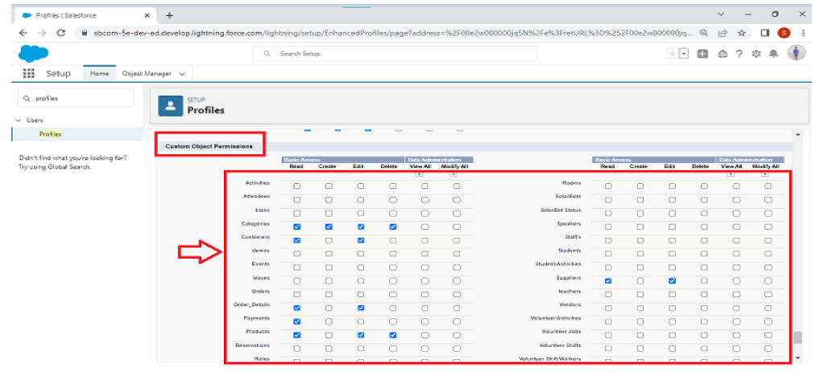

**MILESTONE 6:**

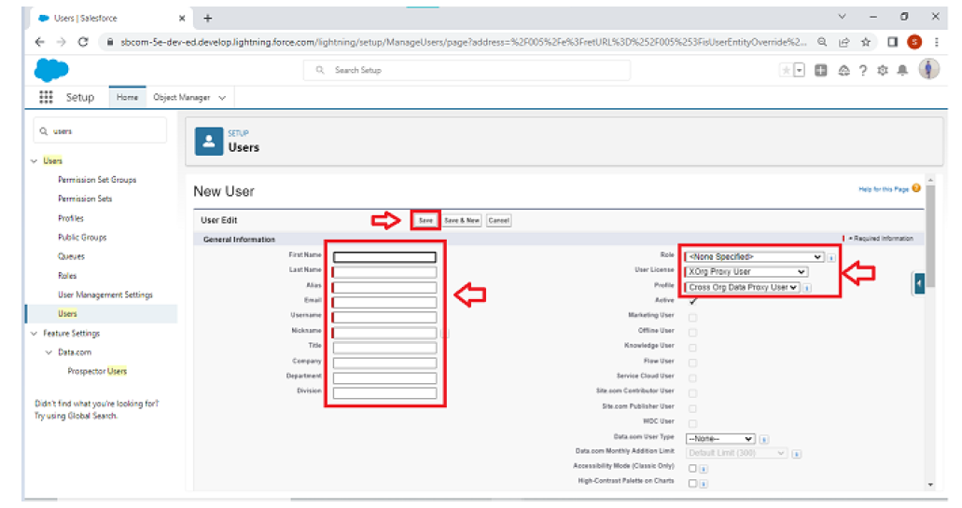

**MILESTONE 7:**

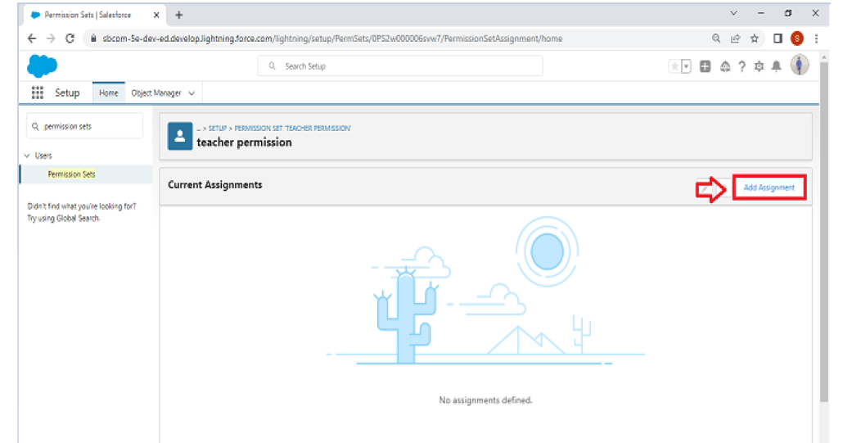

**MILESTONE 8:**

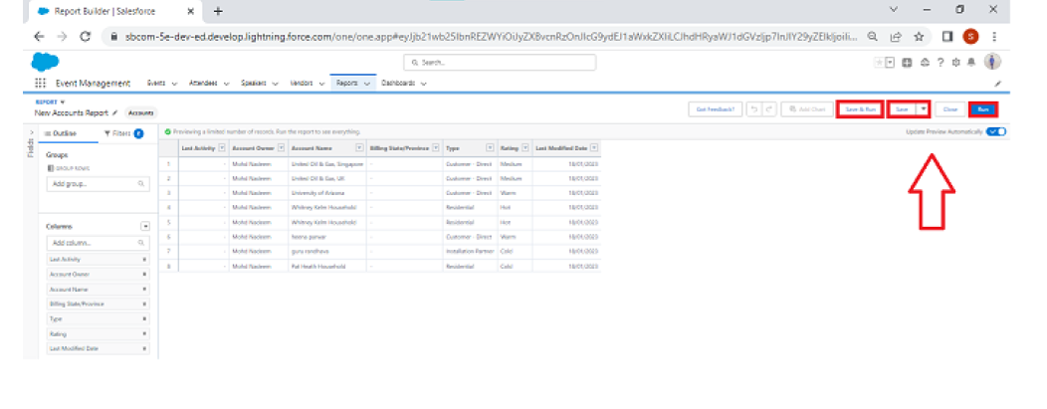

**4.TRAILHEAD PROFILE PUBLIC URL:**

**TEAM LEAD:** <https://trailblazer.me/id/kgajendiran>

**TEAM MEMBER 1:** <https://trailblazer.me/id/loger6>

**TEAM MEMBER 2:** <https://trailblazer.me/id/malim84>

**TEAM MEMBER 3:** <https://trailblazer.me/id/mmathavan2>

1. **ADVANTAGES AND DISADVANTAGES:**

**ADVANTAGES:**

* We had learned the new things which helps to add in our resume as well.
* In the empathy map, we think a lot to complete the tasks.
* We also learned the soft skills i.e., Team work, group discussion, leadership quality etc…
* Chat with mentor option helps a lot to complete these project.

**DISADVANTAGES:**

* In the brainstorming and ideation we faced a lots of difficulties i.e., it has only two trials.
* We are getting more confusions because many mistakes in the given file.

1. **APPLICATIONS:**

* Real time salesforce project.
* BUILD AN EVENT MANAGEMENT platform and also a centralized platform for managing customer accounts, sales leads, activities, customer support cases.
* Salesforce is a massive infrastructure of event management software products that helps marketing, sales, commerce, service and IT teams connect with their customers.

1. **conclusion:**

This project enhance us to learn a lot and will definitely helps in the future.

1. **FUTURE SCOPE:**

This works enhance a better relationship between a customer and the sales which further helps in the development and increases the rate of profit for the companies and industries.